

Course Name : Electronic Circuits

Course Code : CSE251

Section No :06

Group No :

Experiment No : 01

Name of the Experiment : I-V Characteristics and Modeling of Forward Conduction of a Diode

Date of allocation :

Date of submission: 6-1-2020

Submitted To : Surajit Das Barman

Senior Lecturer

Student’s Name : Apurba Roy

Student’s ID :2018-3-60-063

Student’s Name : Monjurul Alam

Student’s ID :2018-3-60-035

1. To measure the I-V characteristics of forward conduction of a p-n junction diode.

2. To determine the models of forward conduction of a p-n junction diode.

Introduction:

Diode is one of the most basic non-linear electronic devices. An ideal diode acts like a switch for electric current, acting as a short circuit for current flow in one direction (forward bias connection) while behaving as an open circuit for current flow in the opposite direction (reverse bias connection). The characteristics of practical diodes are however somewhat different from those of ideal ones. The p-n junction diodes are one of the most popular types of diodes used in the industry. The forward bias current-voltage (I-V) characteristic of a p-n junction diode will be measured in this experiment.

Circuit Diagram:

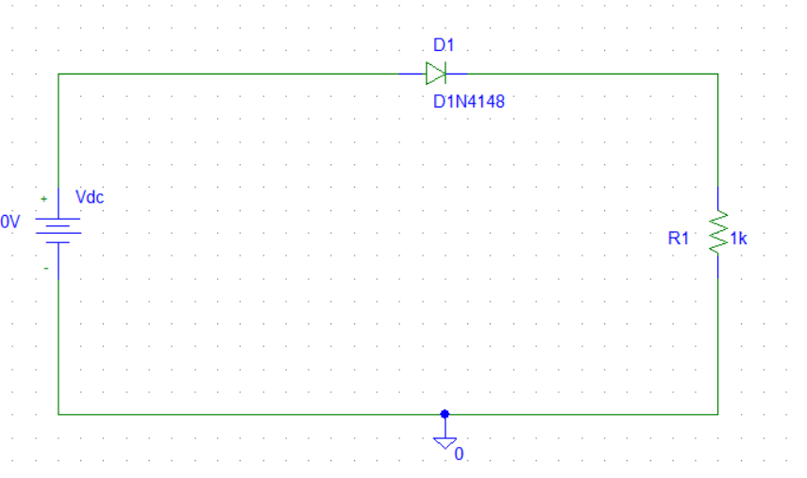

Figure 1. Circuit set up to measure forward bias I-V characteristics of a diode.

**Apparatus:**

* DC power supply
* Digital multimeter
* Diode (1 pc)
* Resistor 1KΩ
* Breadboard
* Connecting wires
* Matlab
* Pspice

DATA SHEET:

|  |  |  |  |
| --- | --- | --- | --- |
| Vs(V) | VD(V) | VR(V) | ID(mA) |
| 0 | 0 | 0 | 0 |
| 0.1 | 0.1 | 0 | 0 |
| 0.3 | 0.3 | 0 | 0 |
| 0.5 | 0.5 | 0 | 0 |
| 0.7 | 0.7 | 0 | 0 |
| 1 | 0.7 | 0.3 | 0.3 |
| 1.3 | 0.7 | 0.6 | 0.6 |
| 1.6 | 0.7 | 0.9 | 0.9 |
| 2 | 0.7 | 1.3 | 1.3 |
| 2.5 | 0..7 | 1.8 | 1.8 |
| 3 | 0.7 | 2.3 | 2.3 |
| 3.5 | 0.7 | 2.8 | 2.8 |
| 4 | 0.7 | 3.7 | 3.7 |
| 5 | 0.7 | 4.3 | 4.3 |
| 7 | 0.7 | 6.3 | 6.3 |
| 9 | 0.7 | 8.3 | 8.3 |
| 10 | 0.7 | 9.3 | 9.3 |
| 12 | 0.7 | 11.3 | 11.3 |
| 15 | 0.7 | 14.3 | 14.3 |

**Ans to the post lab questions:**

1. Using MATLAB

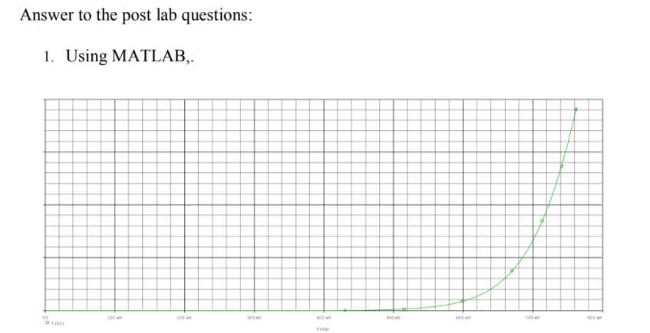

**5**. Simulate the circuit of the figure 1 for a DC bias (VS) range of 0-5 volts using PSpice. Print the ID vs. VS and VD vs. VS plots generated by PSpice and attach them with your report. For simulation, use the DC SWEEP option of PSpice and the diode D1N4148. To modify the diode parameters, select the diode (it will turn red) and go to Edit Model Edit Instance Model (Text). There, replace the values of IS, N, Vj by your values calculated in steps 2 and 3 and click OK.

**Answer:**





**Conclusion:**

* The V-I characteristics or voltage-current characteristics of the p-n junction diode is shown in the figure. The horizontal line in the below figure represents the amount of voltage applied across the p-n junction diode whereas the vertical line represents the amount of current flows in the p-n junction diode
* An ideal diode, in forward conduction act like a short circuit but here in practical diode it consume some voltage to act like short circuit, but still it doesn’t act like short circuit fully because of leak voltage.